In previous section we had a brief introduction to Pivotal Cloud Foundry (PCF). In this section, we will be setting up the PCF environment for development purpose. We will be installing PCF locally and configure the Pivotal Web Services (PWS) console to create an account.  
  
**Creating Pivotal Cloud Foundry Account**

* Go to pivotal cloud foundry page (https://pivotal.io/). Click on “Sign in” and then “Create account” link.  
    
  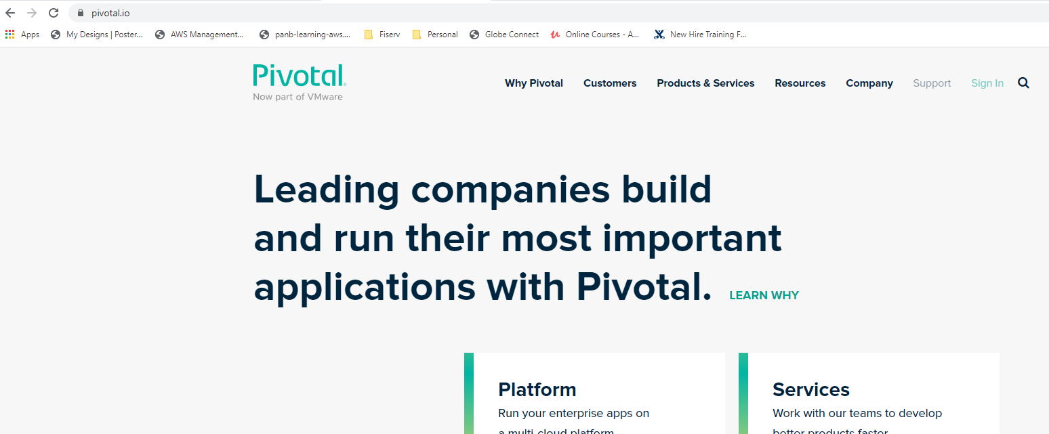
* And then fill the required details  
    
  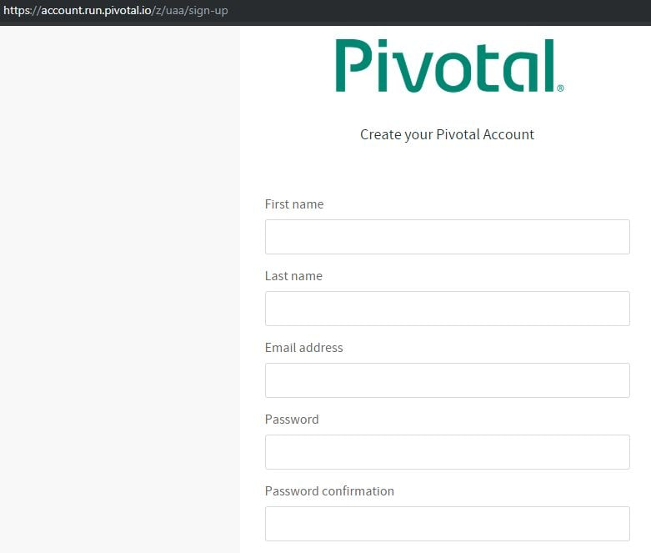

Verify the link received on your registered email.  
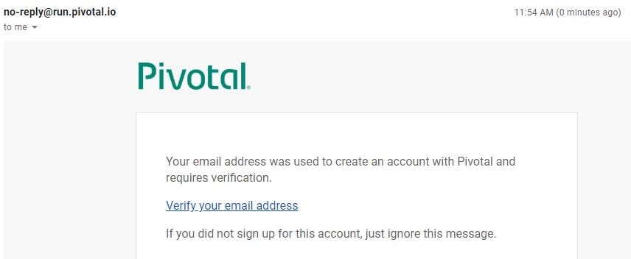

Login to Pivotal Cloud Foundry with your credentials and Select Pivotal Web Services.  
  
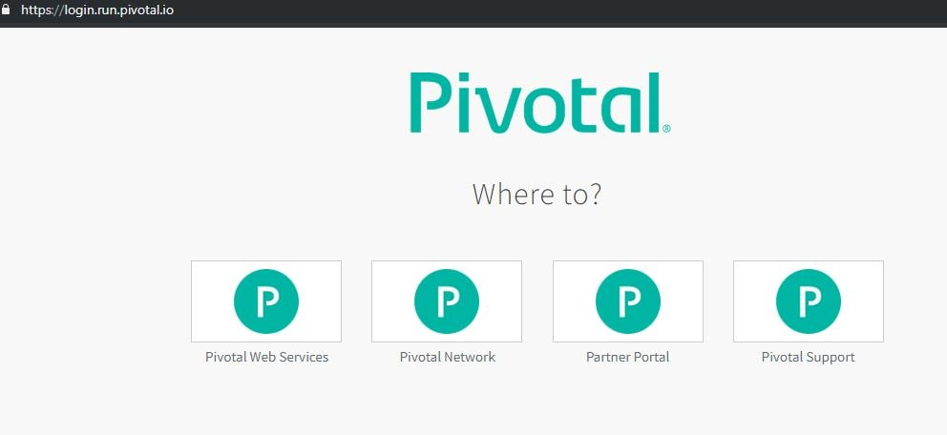

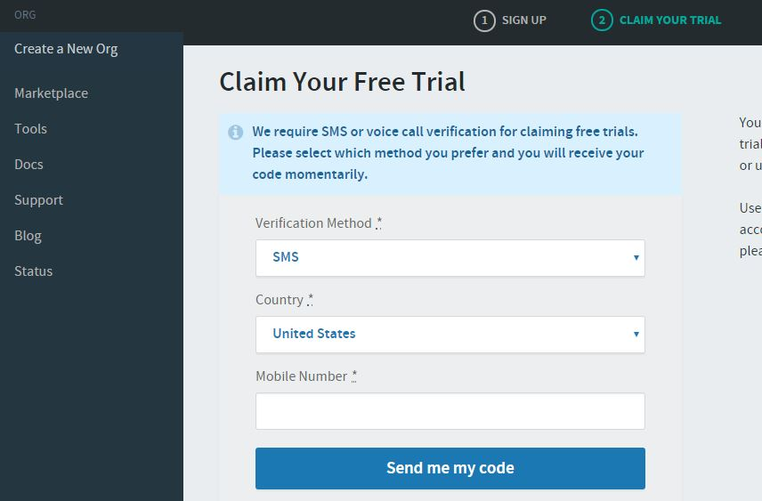  
  
  
  
  
To start the free trial we need to validate the token received on mobile phone.  
  
(In India with Airtel there is a possibility that you will not get the required code. As a work around, send an email from your registered email id to **support@run.pivotal.io**)  
  
Mention that you are unable to get the required code and can they please help. Support team will then do the needful to provide you an access to your free org.  
  
  
**Downloading and installing Cloud Foundry Command Line Interface (CLI)**

The Cloud Foundry (cf) command line interface (CLI) provides a set of commands for managing your apps. We will need to download and install this interface for our windows machine.

* + Download the [CF Windows installer](https://cli.run.pivotal.io/stable?release=windows64&source=github). It will prompt for the download. Save the zip file distribution.
  + After successfully unzip operation, double click on the CF CLI executable. Install this executable-  
      
    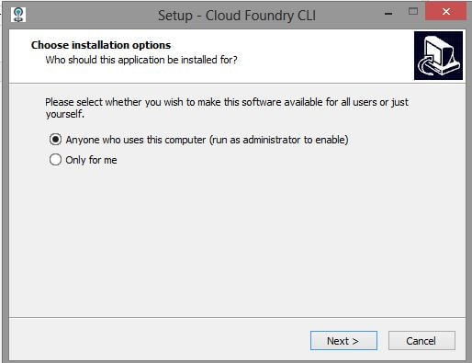
  + To list all of the cf commands and associated help information, use **cf help**. Use **cf command_name -h** to view detailed help information for a particular command.  
      
    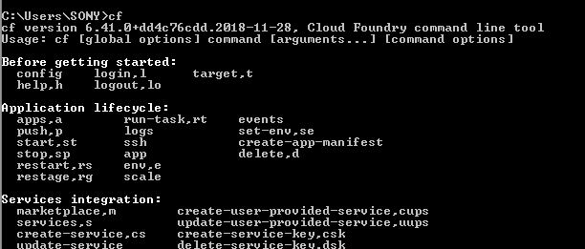

**Orgs/Spaces**  
  
Organization (org) is a development account that encompasses computing resources, apps, and services. It can be owned and used by an individual or by multiple collaborators. Set the org name to be the name of the project you'll be working on or the name of your team. Don't worry - you can change this name at any time.  
  
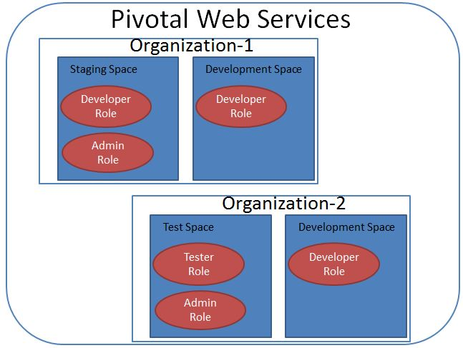

**•** Login to Pivotal Webservices Account using CF CLI.

* Open the command terminal and use the following command

cf login

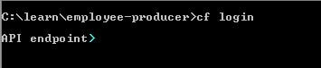

* It will ask for Cloud Foundry API. Enter The following API value-

https://api.run.pivotal.io

Cloud Foundry Login API

* Next it will ask you for the Cloud Foundry credentials  
    
  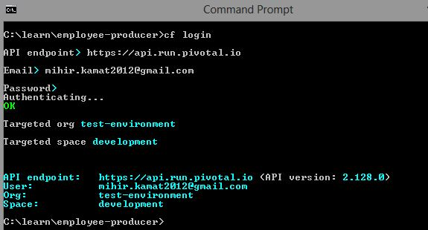

We have successfully login to the PWS console.  
  
Play around with few of the commands…  
  
cf help  
cf help -a

cf help login  
cf login -h

cf --version